1. Lets consider that we work for a development company and I am an incharge of onboarding junior developers.
2. Lets make all junior developers happy by providing their choice of system on which they want to code/do development either it can be LINUX or it can be WINDOWS system etc.
3. But the production system is going to use UBUNTU OS with the latest patches and will be running PYTHON 3 program.
4. We want all the developers to write best PYTHON 3 code on your preferrable OS/system.

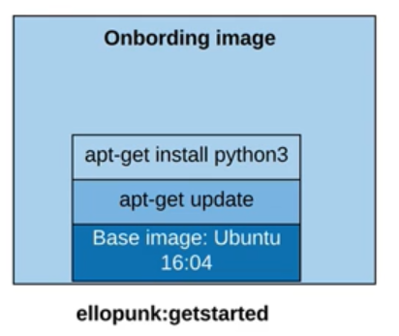

1. When a new developer gets hired, instead of setting them each and every thing and setting their computer in the way we wanted to, we can ask them to download this DOCKER IMAGE from the repository in DOCKER HUB.
2. We can assign them the task of writing a hello-world python program and ask them to push to the repository.

